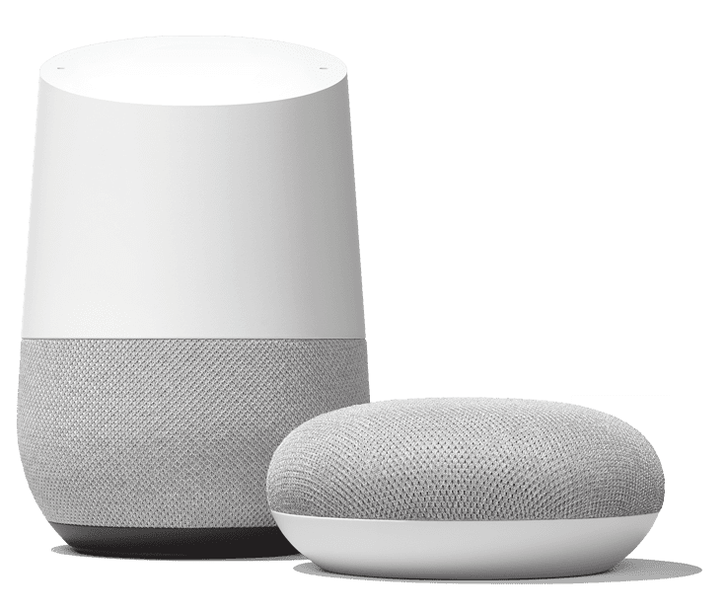
Getting Started
Your Real SAM Speaker subscription currently works on Google Smart Speakers. We plan to have it work on the Amazon Speaker range soon (we are still testing it).
To start talking to Real SAM on your smart speaker, say “Hey Google Talk to Real SAM”. The first time you do this you will be asked to say your activation code that you will have received when purchasing your Real SAM Speaker Subscription. This code links the subscription to the owner of the speaker. It can only be used one time, so please use it on the speaker you wish to use. The email address associated with your speaker and your RealSAM Speaker Subscription, need to match.
If you don’t understand what’s happening, you can say “Go Back” or even “Cancel”. You can also ask for the “User Guide”.
You can interrupt the speaker when it’s talking, by starting with “Hey Google” or ‘Ok Google”. Pause a moment then speak, or if you have the speaker’s accessibility mode turned on, you should then hear a beep then you can speak.
If the speaker asks you a question and you don’t respond within 15 seconds, it will exit Real SAM. If you don’t want to exit but just pause, say “Wait” or “Later”. To exit, say “Goodbye”.
If you have a smart speaker with a screen, you may observe some unusual spelling and grammar. This is because we sometimes need to force Google to pronounce some words and sentences the way you want to hear them.
Don’t forget that outside of talking to Real SAM, your speaker is a powerful tool. We suggest you setup “Voice Match” and also explore what else it does.

Reading Books
Say “What Books do you have? to choose one of the various book sources. You can then search for books by saying, “Find books by John Steinbeck” or, “Search for books with title Harry Potter” or, “Find books about Christmas”. Say “Go to my recent books” to choose a book you have dipped into.

Once you have found a book, Real SAM will offer you the option to start playing it, or add it to your bookshelf to read later.
Once playing a book you can move around it by saying “Pause”, “Play”, “Jump Forward 5”, “Jump Back 10”, “List Contents”. By saying“Where” and “Position” you can find out where you are in the book.

More Entertainment
Real SAM also has Podcasts and Internet Radio Stations available.
Say “Find podcasts about black holes” or “Play The Archers”. Say “List radio stations in Edinburgh” or “Listen to radio about Rock”.
You can also say “Read me the Conversation” to get in depth articles on issues making the news.

Information on Organisations
Real SAM brings together lots of ideas and information which may be of interest to people with sight loss, plus how to get in touch with the various organisations.
To find out about an organisation, say “Tell Me About” and then the organisation name. You can also say “Tell Me About all you have” to get a current list of all organisations that Real SAM has information on.

Getting Help
Please be patient with Real SAM on the Smart Speaker. It’s the first system of its type and will get better all the time, plus you can’t break it.
If you do need help though, you can call our Help Centre in Peterborough during business hours on 0333 772 7708. Enjoy!

