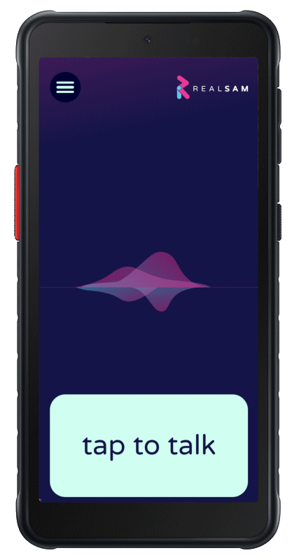
Getting Started
Hold down the Power button on the right hand side until it buzzes, to turn the handset on.
Tap the Talk Pad, which is anywhere on the bottom quarter of the screen, wait for the tone then say “Device Tutorial”. Practice saying this clearly so that you get a good response.
Saying “WiFi Tutorial” or “Configure Wi Fi” is an important first step if your Pocket does not have an activated SIM card installed
Now Tap the Talk Pad and say “My name is Susan” or your name.

Interacting with Pocket
Quite often Pocket will offer you a list of choices. To select from a list, say “Number 1” or “The last one” or “The third one”.
“Say that again” or “Repeat” to hear the last thing said. Say “Go Back” to go back to the last thing you were doing. Say “Stop” and “Continue”, or hold down the Talk button to pause, and hold it again to continue. You can say “Cancel” to start afresh.
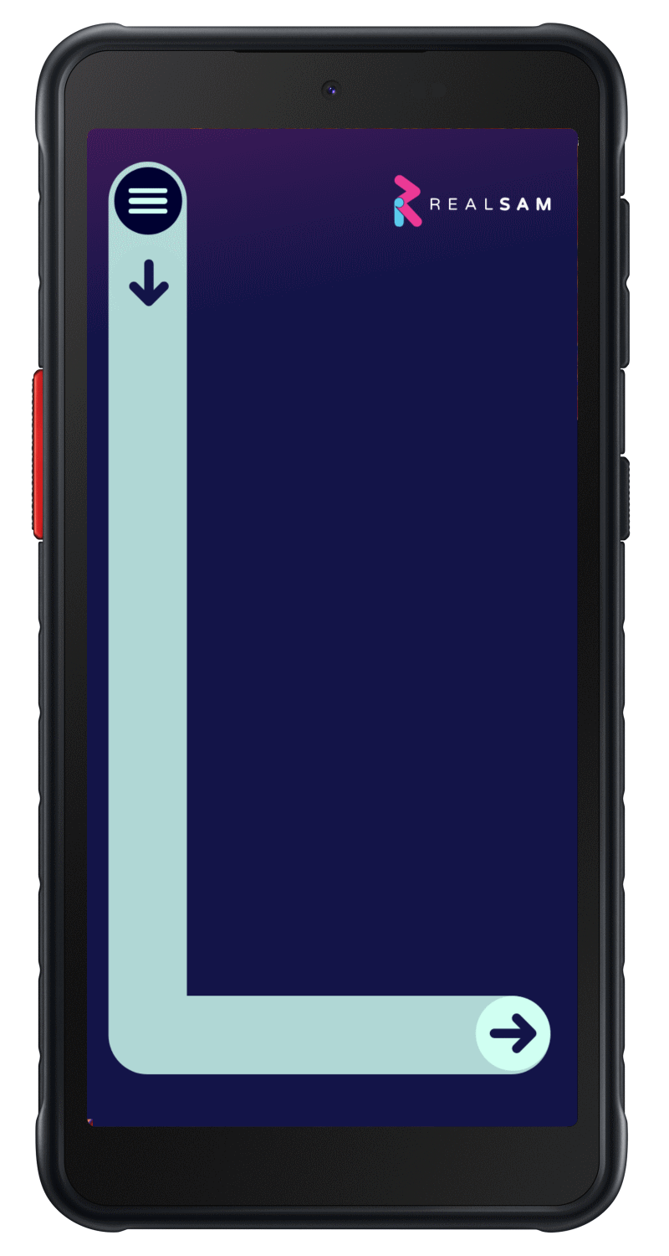
You can also say “Speak Faster/Slower” or “Speak Normally” or “Change your Voice”. You can also cut Pocket off if you don’t want to wait.

Touch Screen Menu
Draw a large capital ‘L’ on the screen with your finger. Starting at the top left, drag your finger down the screen and then across to the right. When the menu appears, slide your finger up and down the menu options until you hear the item you want, then lift it off to make a selection. A voice based and visual user guide are both available on the Handset.

The User Portal
The Portal lets you add contacts in bulk and other useful tasks. Use a computer’s web browser to go to: portal.realsam.co.uk/ Say “Portal login” to the RealSAM Pocket handset to get your username and password details.

Getting Help
Say “User Guide” to access the full user guide. To request specific help on what you are doing, just say “Help”. You can also call or email us. The team will also call you once you have a device to make sure you become comfortable using it.
Helpline: 0333 772 7708 Email: helpline@realsam.co.uk

Using Pocket as a Phone
Calls Say “Call James Bond” or “Call 07812 345 678”. Say “List Recent Calls”.
Messages Say “Send a Message to Jim” or “Text 07812 345 678”. Say “List Messages”.
Contacts Say “Add a Contact for Moneypenny”, and say “Keyboard” to type a number if Pocket is not hearing it correctly. Say “List Contacts” or “Find contacts for James”.

Reading Books
Say “What Books do you have?” for the book sources you can select.
You can search in many ways. Say “Find books by John Steinbeck” or, “Search for books with title Harry Potter” or, “Find books about Christmas”. Say “Go to my recent books” to choose a book you may be currently reading, or “Go to my Bookshelf” to find a title you have lined up to read.
Once you have started reading a book you can say “Table of Contents” of “Jump Ahead 5” and more.

Reading Newspapers
Say “List newspapers” or perhaps “Read me The Guardian”. Then “Which sections do you have?” or “Go to the Sport section”.
Say “Next” to move to the next article or “Headlines” to go back to the headlines. You can also say “Automatic Reading”. Say “Subscribe” to add the Newspaper to “My Newspapers” list.

More Entertainment
Pocket also has Audio Magazines, Podcasts and Internet Radio Stations available.
Say “Find podcasts about black holes” or “Play The Archers”. Say “List radio stations in Edinburgh” or “Listen to radio about Rock”.

Using Pocket as an Assistant
Time | “What time is it in Paris?”
Weather | “What is the weather in Edinburgh?”
Reminders | “Remind me in 10 minutes to check the oven”. Time can be seconds, minutes, or hours only, and not mixed.
Orientation | “Where am I?” for your current location or “What's around here?”.
Navigation | “Start Locations” to get as the crow flies navigation to your points of interest. Say “Label Location” and “List Locations” to manage your list.
Magnifier | “Start Magnifier” to use the Video Magnifier with touch screen controls.
Sighted Help | “Be My Eyes” to have your handset connected to a volunteer, who can talk to you through the handset, and see what the camera sees.

