RealSAM Pocket Plus  Quick Start Guide  (v1 202505) | 

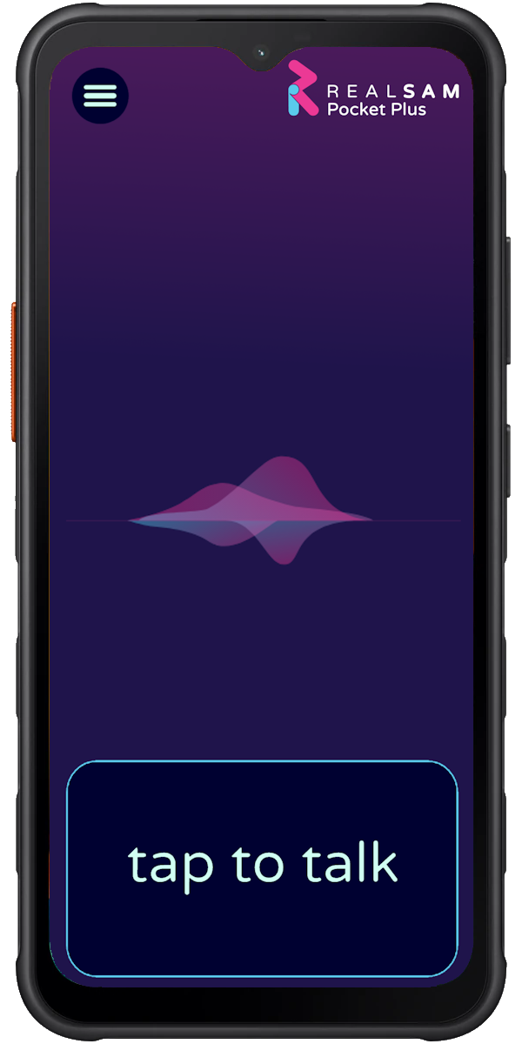 | Getting Started  Call the RealSAM Support Team once you have your new Pocket Plus. We will help you set it up and learn to use it.  Call Support Helpline 0333 772 7708
Turning On the Device
- Hold down the Power button on the right-hand side until it vibrates

Activating Voice Control
- Tap the Talk Pad (anywhere in the bottom quarter of the screen), wait for the tone and speak
OR
- Press the Red Button on the left side, wait for the tone then speak

Wi-Fi Setup - if your device does not have an activated SIM card:
- Tap the Talk Pad and say 'WiFi Tutorial' or 'Configure WiFi'

User Guides
- A voice-based guide is available on the handset and a visual guide can be found on the website https://realsam.co.uk/support

Using Pocket Plus

Pocket Plus is our premium, most intuitive device using cutting-edge AI. With other devices very specific commands and phrases need to be used, however Pocket Plus can understand more natural speech, so try speaking to it and asking some questions!

Here are some helpful commands to get you started:
- ‘Hello RealSAM, my name is …’ - to introduce yourself
- ‘Say that again’ or ‘Repeat’ – to hear the last message again
- ‘Go Back’ – to return to the previous action
- ‘Stop’ and ‘Continue’ (or hold down the Tap to Talk button) - to pause or resume an action
- ‘Cancel’ – to start again
- ‘Speak faster’, ‘Speak slower’, ‘Speak normally’, or ‘Change your voice’ – to control speech style
- You can interrupt Pocket Plus by tapping the Talk Button and speaking at any time.
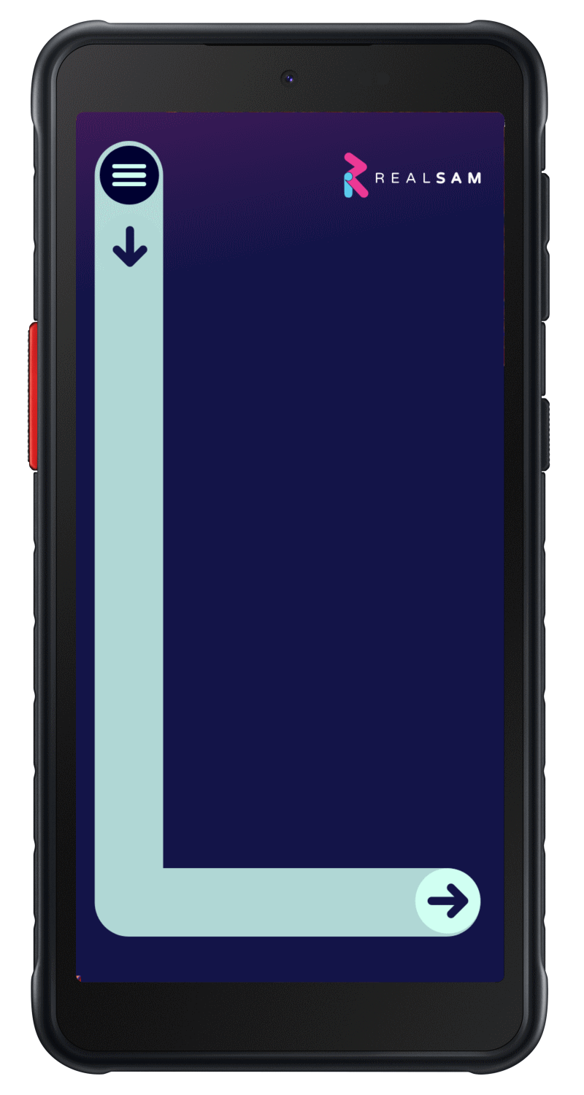

Touch Screen Menu
- Draw a large capital ‘L’ on the screen:
Start from the top left, drag your finger down, then right
- When the menu appears, slide your finger up or down to explore options
- Lift your finger when you hear the item you want.

The User Portal
- Use the User Portal to add contacts and perform other tasks on a computer
- Visit: https://portal.realsam.co.uk
- To get your login details, say: 'What is my Portal login' to your device.

Getting Help
- Say 'User Guide' for the full guide
- Say 'Help' for context-sensitive assistance
- You can also contact us:
Phone: 0333 772 7708
Email: helpline@realsam.co.uk
After setup, a team member will also contact you to ensure you're comfortable using your device.

Making Calls & Sending Messages on Pocket Plus
Calls
- Say: 'Call <Name> e.g. Call James Bond' or 'Call 07812 345 678'
- Say: 'List recent calls'
Messages
- Say: 'Send a message to Jim' or 'Text 07812 345 678'
- Say: 'List messages'
Contacts
- Say: 'Add a contact for Moneypenny'
- Say: 'Keyboard' to type a number if it's misheard
- Say: 'List contacts' or 'Find contacts for James'

Reading Books
You can search for books in many ways.
- Search examples:
  - 'What books do you have by Hemingway?'
  - 'Search for books with title Harry Potter'
  - 'Find books about Christmas'
- Resume reading with:
  - 'Go to my recent books'
  - 'Go to my bookshelf'
- While reading, you can say:
  - 'Table of contents'
  - 'Jump ahead 5 minutes'

Reading Newspapers
Say:
- 'List newspapers' or 'Read me The Guardian'
- 'Which sections do you have?' or 'Go to the Sport section'
- 'Next' – go to the next article
- 'Headlines' – return to headline list
- 'Automatic reading' – continuous reading
- 'Subscribe' – add to your personal newspaper list

More Entertainment
Pocket Plus includes audio magazines, podcasts, and internet radio.
Examples:
- 'Find podcasts about black holes'
- 'Play The Archers'
- ‘List radio stations in Edinburgh'
- 'Listen to radio about rock'

Using Pocket Plus as an Assistant
Time & Weather
- 'What time is it in Paris?'
- 'What is the weather in Edinburgh?'
Reminders
- Say: 'Remind me in 10 minutes to check the oven.'
Orientation & Navigation
- Say:
  - 'Where am I?'
  - 'What’s around here?'
  - 'Start Locations' – for navigation
  - 'Label location' – name a place
  - 'List locations' – review saved places

Sight Assistant
- Say: 'Start Magnifier' to use the video magnifier with touch controls.
Be My Eyes
- Say: 'Be My Eyes' to connect with a volunteer who can see through your camera and guide you.
Other Features available include:
- Whatsapp
- Hands-free option (Speak to Talk)
- Changing timeout and other settings
- Sleep Timers (for eg. when listening to books)
- Dictation Mode
- Text on Screen options
- Emergency Assistance Contact
- Sight Assistant (V3) advanced features
- Navilens
- Using TalkBack and other accessibility features
- Audio Books and Newspapers advanced features
- GoogleMaps
- Google Chrome for browsing the internet

Managing SIM Cards
If you purchased the Pocket Plus version that is not automatically bundled with a plan from O2, you have three choices around how you would like to connect. Note, if you have purchased Pocket Plus with an O2 plan you do not need to do anything to activate the SIM card.

1. Use Pocket Plus on WiFi
You can use Pocket Plus on any WiFi network. Just say 'Configure WiFi' and Pocket Plus will list all the WiFi networks it can discover, then ask you to select one and enter its password. Use the touchscreen keyboard to select each letter. Slide your finger onto the letter and lift your finger to select it.

2. Activate the pre-installed O2 SIM
Your RealSAM Pocket Plus comes with a SIM from O2 pre-inserted. If you would like to activate this SIM, just call the RealSAM Helpline on 0333 772 7708 and let them know who you are. You can also email them on helpline@realsam.co.uk.

3. Inserting a SIM
You can use SIM cards from almost any provider, as long as you are using a nano-sized SIM card. To use your own SIM Card:
- Remove the back cover of the device, then remove the battery.
- Remove the O2 SIM card from the slot on the left-hand side when looking at the back of the phone.
- Insert your SIM in its place. The missing corner of the SIM should be to the top left, Put the battery back in, fit the cover securely to ensure it stays waterproof.
- You may need to restart Pocket Plus twice to ensure the new network is recognised.

