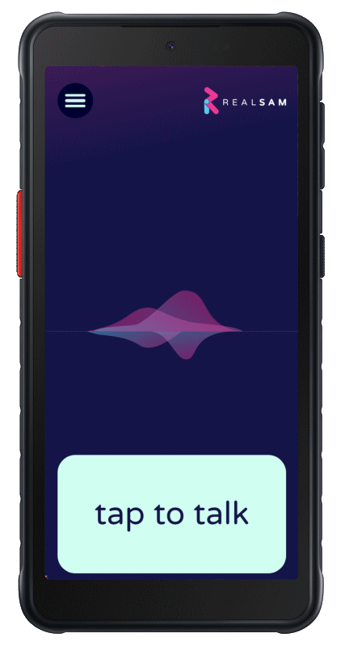

Getting Started
Welcome to your new RealSAM Phone.
This guide will help you take your first steps, even if you are not confident with technology.
If you get stuck, please call our friendly support team on:

📞 0333 772 7708
E: helpline@realsam.co.uk

Step 1: Turning On Your Phone
- Find the Power button on the right side of your phone.
- Press and hold it for about 3 seconds.
- The phone will buzz. Let go of the button.
- Wait until you hear the welcome message.

Step 2: Talking to RealSAM
- Tap anywhere on the bottom quarter of the screen (this is called the Talk Pad).
- Wait for a short beep.
- Say what you want the phone to do.
- Try saying:
  - “Device Tutorial” – to practice using your phone.
  - “Wi-Fi Tutorial” – to connect to Wi-Fi.
  - “My name is …” – so the phone learns your name.
- If you want to stop what you are doing, tap the Talk Pad and say “Cancel”.

Step 3: Helpful Things to Say
- Quite often, RealSAM will offer you a list of choices. To select from a list, say “Number 1” or “The last one” or “The third one”.·
- “Say that again” – repeat the last thing said.
- “Go back” – return to the previous step.
- “Stop” or “Continue” – pause and resume.
- “Speak slower” or “Speak faster” – change the voice speed.
- “Help” – get guidance at any time.

Step 4: Making Calls
- Say “Call [person’s name]” – e.g. “Call Sarah”.
- Or say “Call [phone number]” – e.g. “Call 07123 456 789”.
- Say “List recent calls” to hear who you spoke to last.

Step 5: Sending Messages
- Say “Send a message to [name]”.
- Or say “Text [phone number]”.
- Say “List messages” to hear recent ones.

Step 6: Adding Contacts
- Say “Add a contact for [name]”.
- If the phone doesn’t hear a number correctly, say “Keyboard” to type it in.
- Say “List contacts” or “Find contacts for [name]”.

Step 7: Other Useful Commands
- Time → “What time is it?”
- Weather → “What’s the weather in London?”
- Reminders → “Remind me in 10 minutes to check the oven.”
- Location → “Where am I?”
- Navigation → “Start locations.”
- Magnifier → “Start magnifier.”
- Sighted help → “Be My Eyes.”

Step 8: Connecting to the Internet
- Your phone needs Wi-Fi or a SIM card to connect.
- Wi-Fi → Say “Configure Wi-Fi”, then follow the instructions.
- O2 SIM (already inside) → This is already activated if you bought a mobile plan.
- Your own SIM → Insert a nano SIM card into the slot on the left side of the phone. You may need to Restart twice for your phone to connect.

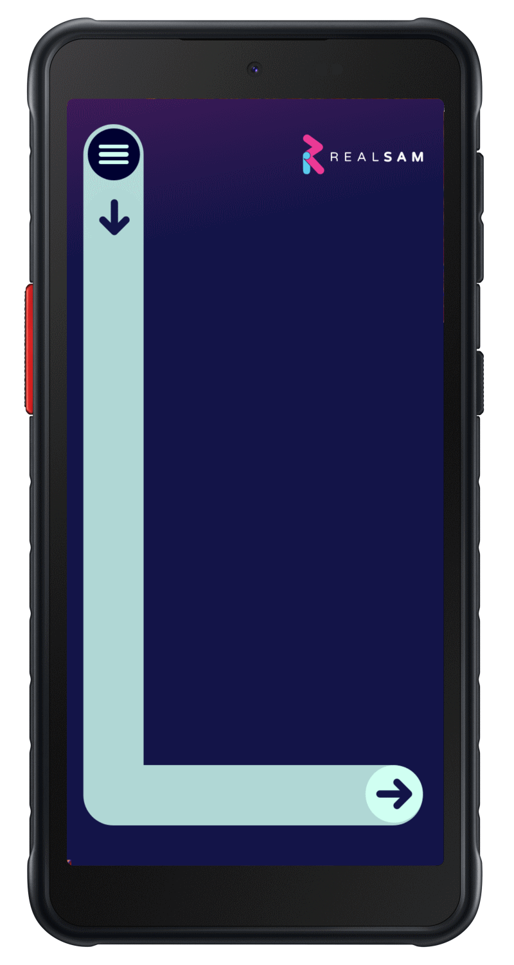
Step 9: The Touch Screen Menu (Optional)
If you prefer using the screen:
- Draw a large capital L with your finger (down, then across).
- Slide your finger up or down to hear menu options.
- Lift your finger to choose your selection.

Step 10: Getting More Help

Accessing the RealSAM Customer Portal
The Portal is a useful tool for adding contacts in bulk and other useful tasks. Use a computer’s web browser to go to: portal.realsam.co.uk. Say “Portal login” to the RealSAM Phone to get your username and password details.·
- Say “User Guide” for full instructions.
- Call our helpline if you need personal support: 📞 0333 772 7708
- We will also call you soon to make sure you’re comfortable with your new phone.
✨ Tip: Don’t worry if you make a mistake. Just say “Cancel” and start again.

